**Homoscedasticity and Heteroscedasticity**

Is an assumption in Linear Analysis. First we must first understand residual value of the dependent variable in the regression Analysis .

**Residual values** are simply the **error terms**. It is the differentbetween observed valued(actual) and the predicted value of dependent variable. Homoscedasticity refers to whether these residual are equally distributed or whether they tend to cluster together at some values and spread far at some other values.

If the residuals are equally distributed it is called Homoscedasticity.

If the residual tend to cluster together at some values and spread far at some other values it is called Heteroscedasticity

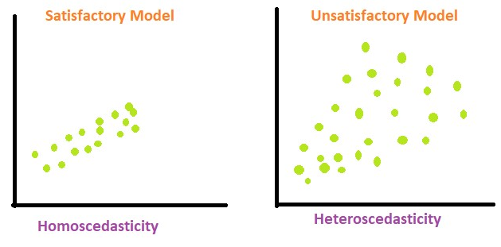

**The significance of Homoscedasticity.**

Check for homoscedasticity when using regression to ensure the reliability of your model's predictions.

Valid Inferences: Assess homoscedasticity to maintain the validity of statistical inferences and confidence intervals derived from your regression results.

Residual Analysis: Examine residuals by plotting them against predicted values to visually check for consistent variability.

Model Reliability: Homoscedasticity is crucial for reliable and consistent insights across different levels of the independent variable(s) in your regression model.

Corrective Actions: If heteroscedasticity is detected (inconsistent spread of residuals), consider corrective actions like variable transformations for more dependable results.

Essential Step: Checking for homoscedasticity is a key step in building trustworthy regression models, ensuring that the relationships observed hold consistently throughout your data.